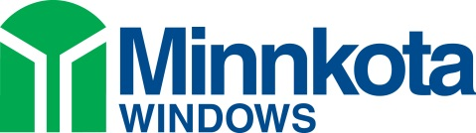
2324 Main Ave. W.
West Fargo, ND 58078

2019 Manufacturer’s Certification Letter

This letter certifies that all Minnkota Windows products meet or exceed the Energy Star program requirements in all climate zones in which the windows are installed when delivered with an ENERGY STAR label.

Thermal performance criteria for Minnkota Windows’ ENERGY STAR® labeled products have been independently tested as verified by the National Fenestration Rating Council (NFRC).

For tax purposes, homeowners are advised to keep their purchase receipt(s). As in all tax matters, the taxpayer is advised to consult their tax professional.

Under penalties of perjury, I declare that I have examined this certification statement, and to the best of my knowledge and belief, the facts are true, correct and complete.

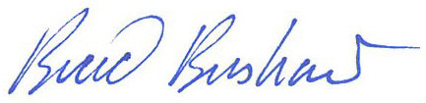
Brad Bushaw
General Manager
Minnkota Windows

